MongoDB Server

MongoDB Version 3.2
OS - CentOS7 64 bit

MongoDB Version 3.2 installation on CentOS 7:

Step 1: Perform the following command to create a repo file using vi editor
vi /etc/yum.repos.d/mongodb-org-3.2.repo
So that you can install MongoDB directly, using yum.

Step 2: in that repo file paste the following contents into it and save the file.

[mongodb-org-3.2]
name=MongoDB Repository
baseurl=https://repo.mongodb.org/yum/redhat/$releasever/mongodb-org/3.2/x86_64/
gpgcheck=1
enabled=1
gpgkey=https://www.mongodb.org/static/pgp/server-3.2.asc

Step 3: After save the file, run the following command to install the MongoDB (version 3.2).

sudo yum install -y mongodb-org

Step 4: Then, we need to install semanage with following command

yum -y install policycoreutils-python

Step 5: Perform the following command for adding MongoDB port using semanage

semanage port -a -t mongod_port_t -p tcp 27017

Step 6: Run this command to disable the selinux SELINUX=disabled

Step 7: You must reboot the system for the changes to take effects.

Step 8: After restart, edit the mongodb.conf file through following command

vi /etc/mongodb.conf

Find the bindip in network interfaces section, and add the mongoDB machine IP address after (127.0.0.1) default IP by adding comma (127.0.0.1,xx.xx.xx.xx).

Please find the following image for reference.
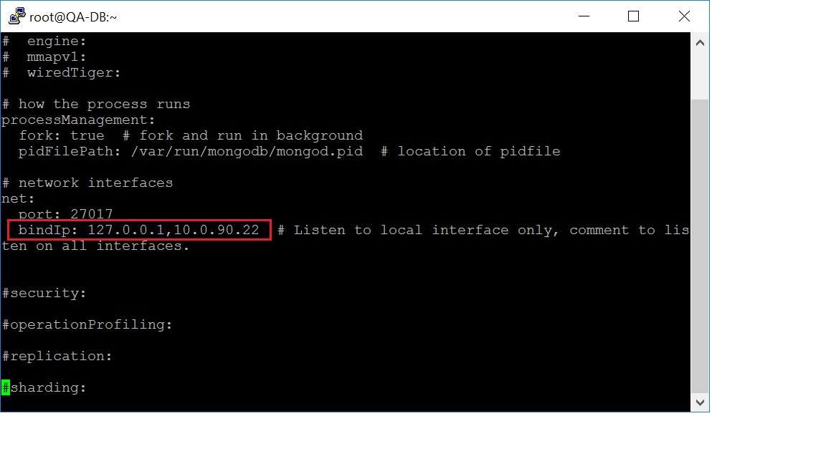

Step 9: And, run the following command to start mongodb as a service.

mongod --fork --dbpath /var/lib/mongo/ --logpath /var/log/mongodb.log --logappend

Note: To Kill/Stop the mongodb process use this command
( mongod --dbpath /var/lib/mongo/ --shutdown )

Step 10: Perform following command Firewall ID installation.
sudo yum install firewalld

Step 11: After installed firewalld, we have to open the mongoDB port 27017

Perform following command to add the mongoDB port into the firewall
firewall-cmd --zone=public --add-port=27017/tcp --permanent

Step 12: Perform the following reload command to take the effects applied.
sudo firewall-cmd --reload

Step 13: After adding the port, We have to stop the mongoDB service and start the mongoDB service again.

These are the command to stop and Start the mongoDB service.
Stop Command - mongod --dbpath /var/lib/mongo/ --shutdown
Start Command - mongod --fork --dbpath /var/lib/mongo/ --logpath /var/log/mongodb.log --logappend

